Applications of Superconductivity

Medical diagnostics
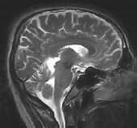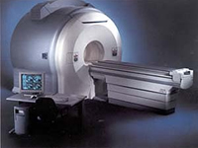
MRI of a human skull An MRI scanner

An area where superconductors can perform a life-saving function is in the field of biomagnetism. Doctors need a non-invasive means of determining what's going on inside the human body. Magnetic resonance imaging (MRI) is an imaging technique used primarily in medical settings to produce high quality images of the inside of the human body. MRI is based on the principles of nuclear magnetic resonance (NMR), a spectroscopic technique used by scientists to obtain microscopic chemical and physical information about molecules. By impinging a strong superconductor-derived magnetic field into the body, hydrogen atoms that exist in the body's water and fat molecules are forced to accept energy from the magnetic field. They then release this energy at a frequency that can be detected and displayed graphically by a computer. From this information a measure of the soft tissue in a person’s body can be computer generated without the need for invasive surgery or without the inherent disadvantages of using seismic energy in ultrasounds.

Smaller magnetic solenoids can be placed around a person’s body to follow the contours of the body. By changing the radio frequencies of the instrument and with the use of computer reconstruction, three-dimensional maps of the soft tissues of a patient can be made that are highly detailed and accurate. The ability to measure magnetic flux precisely is used in a SQUID (Superconducting Quantum Interference Device). This is an instrument to measure tiny magnetic fluxes that generate electrical impulses in the device. Magnetic fields as small as 10⁻¹³ T occur with small variations in current within the brain or the heart. These provide important diagnostic information for doctors.

The magnetic solenoids need to be large enough to allow a person to enter. To produce a magnetic field of 4 tesla, an ordinary solenoid winding would have to be a metre thick. There would be several hundred kilowatts of power dissipated as hear for every metre length of conductor. With superconducting alloys of tin-niobium, magnetic fields of 4T can be established easily. Also, once the desired strength of magnetic field is energised, that is, the current level in the superconducting solenoid is achieved; it runs in a persistent current mode”. In other words, the current is cycling around the solenoid without energy loss. There fore, the device does not require the input of any more electric power to maintain the magnetic field. Normal solenoids would require constant power input.

